1. ENGINEER’S Day CELEBRATION on 1st Oct 16 at COEP AUDITORIUM

To celebrate the blissful occasion of Engineer’s day, Alumni association of GECA organised a small interactive event at Pune.

The event was held on the evening of 1st October at COEP auditorium.

Various achievements of our respected alumnus like awards, research, articles and projects were exhibited on this beautiful evening. It was followed by our senior alumnus giving crucial guidance on topics of common interest to all.

This event was organised by honourable

Shirish Tambe (President AAGECA)

Dr R Joshi (Chairman Pune chapter AAGECA)

Sunil Bhatambrekar (Secretary Pune chapter AAGECA)

And managed by

Atul Pahilwan (mech 15)

Vijay Dhoke (mech 04)

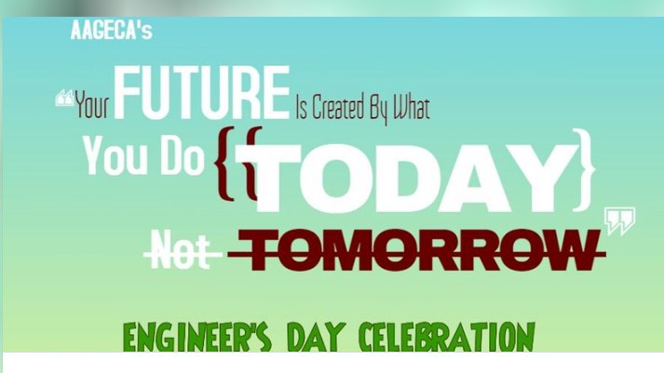

2. GET TOGETHER OF GECA 1981 BATCH

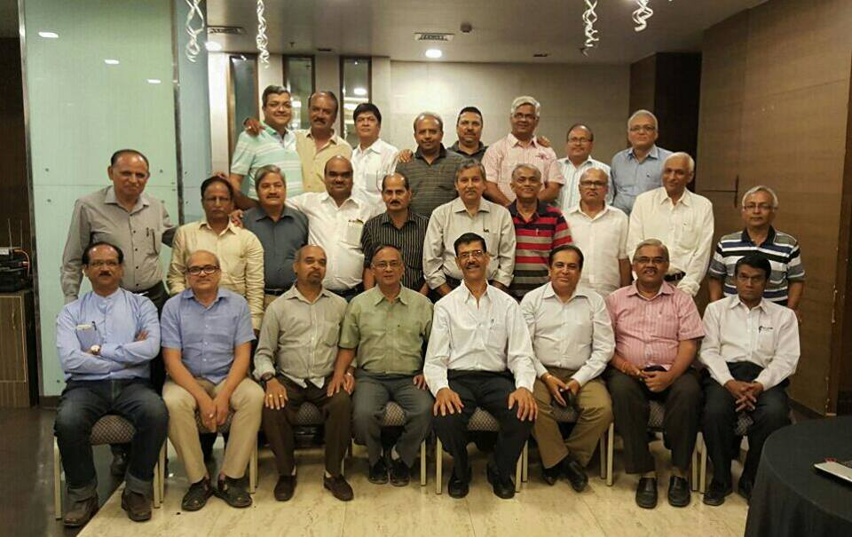

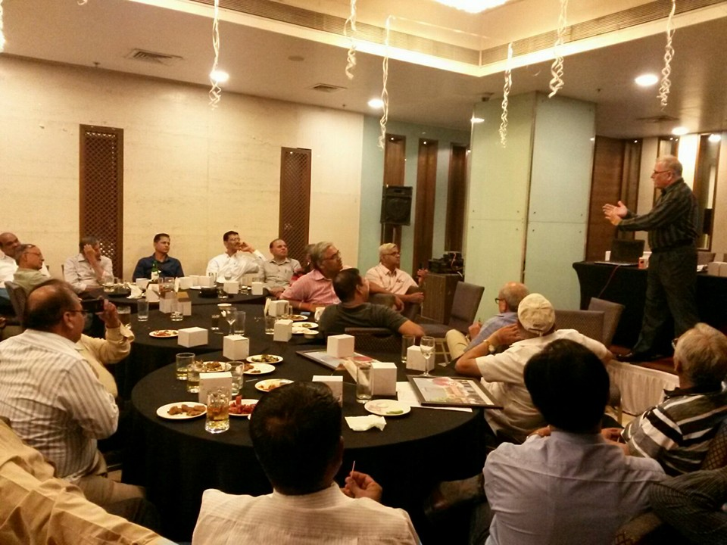

3. AAGECA ALUMINI DINNER MEET on 4TH DEC 14 at COEP AUDITORIUM

